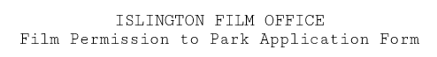

- Please complete and return to info@islingtonfilmoffice.co.uk.
- We require 3 working days’ lead in time. If you are submitting your application on the last available day, please call 0207 620 0391 to confirm it has been processed.

- Permissions to Park (PTPs) are for technical and facilities vehicles only, not for crew cars. A maximum of eight PTPs are available per production per day.
- PTPs can be used to park on the given day, for the full day, in any available pay-by-phone (PbP) / pay-and-display (P&D) or resident permit bays (or a mix of both / all).
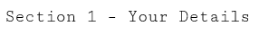
- PTPs are non-refundable or amendable - please ensure all VRNs, CPZ choice and dates are correct.
FilmApp reference number | ISLFIL00
Name of applicant
Name of production company
Name of production
Email address
Phone number
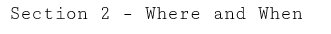

Please check the operational hours for the Controlled Parking Zone (CPZ) in which you wish to park as you may not need a PTP, particularly on Saturday or Sunday.
CPZ (click here for map)
Vehicle make(s) and model(s) *if known*
Vehicle registration number(s) *required*
Date(s) permit required

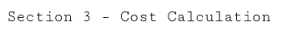

Please calculate payment. Permissions to park are £28.30 per vehicle per day and an administration fee will be charged on top on a case by case basis.

Date | Number of permits | Cost | Total
 |  | @ £28.30 each | £
 |  | @ £28.30 each | £
 |  | @ £28.30 each | £
 |  | @ £28.30 each | £
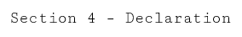

I declare that all information given in this application is true, and I understand that the permissions to park are for film technical / facilities vehicles only, not private cars (unless agreed beforehand). By returning this form I confirm that I have read and accepted the essential information and guidance notes below.

Who can apply?
PTPs are often used in an area where there are no suitable parking bays for a suspension or the lead in time for a suspension is not available; and where the activity is intermittent. The length of time a permission to park is valid for is specific to each application.

Vehicles should not:
• be parked in bus lanes and bus stops
• cause an obstruction or danger to pedestrians and other road users
• be parked on school ‘keep clear’ markings, pedestrian crossing zigzags or emergency service access markings
• be parked on TfL red routes and cycle tracks
• be parked on footways, dropped kerbs and entrances
• be parked on single or double yellow lines
• be parked in disabled permit, motorcycle, electric car, car club, business permit and diplomatic bays

Where do I display my PTP?
PTPs are now generated electronically and a ‘notice of non-enforcement’ for the VRNs is sent to the Parking Wardens. Please ensure a “Film Unit” sign is displayed on the vehicle dashboard.

Payments
Payment must be made by debit or credit card via the Islington Film Office payment portal prior to the PTP(s) being processed – cheques and American Express are not accepted. Alternatively, payment can be made by BACS – proof of payment is required. Once paid, your confirmation of your PTP(s) will be emailed to you.

How do I apply?
Complete the form overleaf and return to info@islingtonfilmoffice.co.uk. You will also need to complete the online filming application (FilmApp) at www.filmapp.org/islington if you have not already done so. PTPs cannot be processed without a FilmApp to relate them to.

Data protection
No personal information you have given us will be passed on for commercial purposes. Our policy is that information will only be shared among officers and other agencies where the legal framework allows it, and where it will help to improve the service you receive and to develop other services. All information and prices are correct at the time of print and may be subject to change without prior notice.

